Memorial Tree
Please complete and return with your check to the Church Office:
Dedication of a brass leaf on the NMJMBC Perpetual Praise Tree for the following:
Name of Donor_______________________________________________________________
Address:____________________________________________________________________
Phone:_____________________________________________________________________
Donation Amount:____________________________________________________________
Number of Leaves:________________________________
2 Rows Limit 120 characters (including spaces):
□1.__________________________________________________________________
□2.__________________________________________________________________

Donation Form for Engraved leaf
New Mount Joy Missionary Baptist Church Perpetual Praise Project
The Memorial tree is a Loving Remembrance

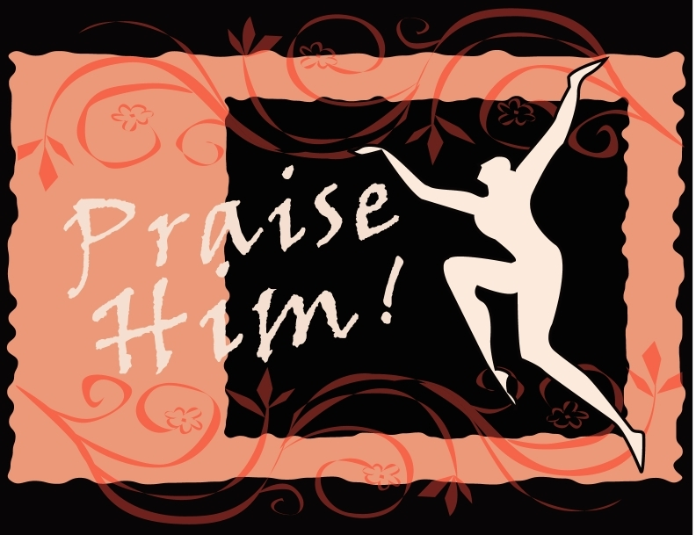

Remember Me…
Remember a loved one, or honor a relative or friend by having a lasting memorial in their honor. Consider commemorating a special event, or day with a leaf.

New Mount Joy Missionary Baptist Church

Perpetual Praise Project Program Description

Making a Donation
When a new leaf is requested, the leaf will be engraved and attached to the memorial tree in the church gathering area with your special wording.

Remember!
☑ Participation in memorial is voluntary.
☑ Donor designates how money will be spent. If no designation is made, donation will go into the memorial fund which is administered by the Board of Trustees.
☑ Donation form (on back of this page) is completed.

Payment
The donation for an engraved leaf is $100. Interested donors shall return the completed donation form and check to the church, with all checks being made out to NMJMBC/Memorial Tree.
Leaf $100

New Mount Joy Missionary Baptist Church
“Where the Healing Waters Flow”

Come Worship With Us!
1725 Division Street
Baltimore, Maryland 21217
Phone: 410.225.7920
Pastor: 443.271.7894
Perpetual Praise Project

